Database Management – BUSA 526
Week #2 Assignment

- A customer can place an order for different products sold by a retailer. A product may be sold on multiple orders and an order may be for many products.

Solution:
-A customer can place multiple orders or 0 and an order can only have one and only customer (1:M).
- An order can include multiple products and multiple products can have multiple orders or 0 (M:N).

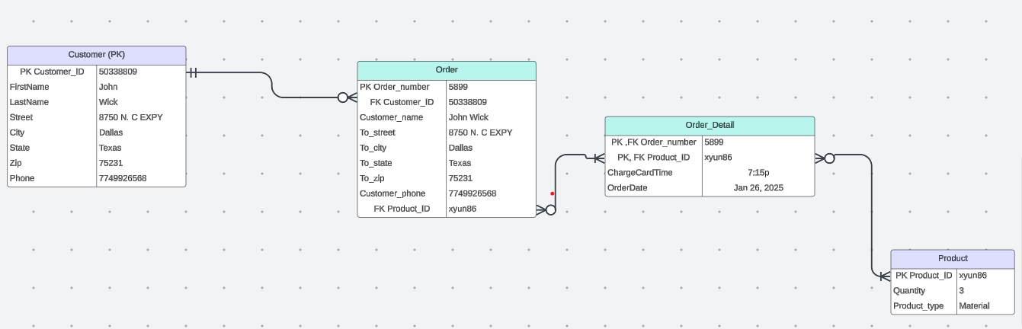

- An academic department at Texas A&M Commerce University offers multiple curricula and a curriculum is offered by one academic department.

Solution:
- A department offers 1 or multiple curricula (1:M).
- Each curriculum is associated with one and only one department (M:1).

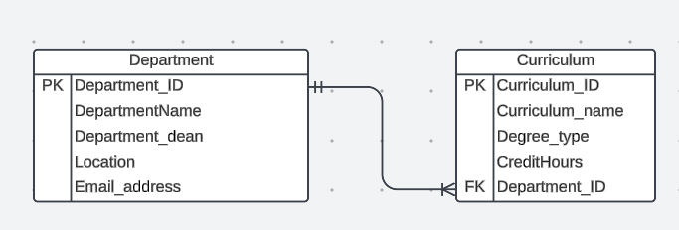

- The Marketing and Business Analytics Department at Texas A&M Commerce University offers courses that may have several prerequisites. Some of these courses may be a prerequisite to other courses.
Solution:
- Some courses have multiple prerequisites or 0 (recursive M:N).

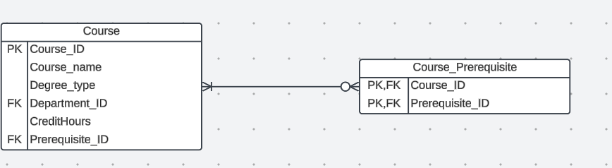

- An employee at Texas A&M Commerce University may work on different projects that may be run at multiple locations.

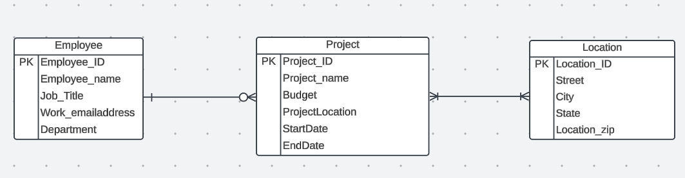
Solution:
- An employee may work on multiple projects (1:M).
- A project may take place at multiple locations (M:N).

PART 2

System thinking focuses on understanding the connection between one or many entities of a system. I use information that I got from watching the linkedin labs video to have an idea of how I should create the ERDs and what variables I can use to make the connection easier between the entities.
Some variables of an entity are found in other entities variables also as a “Characteristic”. In the first exercise for example, the variable “Customer_ID” originating from the Customer table was a variable in the Order table that’s why it is a Foreign Key. For exo a. system thinking helped identify the need for a junction to facilitate the many-to-many relationship happening between the orders and products tables; the “Customer_ID” in the junction table “Order_Detail” became at the same time a Primary Key and a Foreign Key in that table.

And for the Courses and Prerequisites scenario, I recognized a recursive relationship since the course and the prerequisites are absolutely the same thing but to get access to a course you may need to get some classes. Dealing with the many-to-many relationship is a challenging experience, you have to think of the relationships in both senses and to represent them graphically to help facilitate the understanding was not easy to do as well.

PART 3

I find my first use of LucidCharts software interesting to discover. It is quite easy to understand how the software works with creating the ERDs illustrations. I also ask ChatGPT to help me understand how to properly use the many-to-many and recursive relationships so that I can create the entity relationships diagrams.

